# STUDENT RECORD MANAGEMENT SYSTEM A PROJECT REPORT

**CSA0937-PROGRAMMING IN JAVA FOR CLOUD APPLICATIONS SUBMITTED BY**

# K.PAVAN KUMAR

**(192111173)**

# IN PARTIAL FULFILMENT FOR THE AWARD OF THE DEGREE OF

**BACHELOR OF ENGINEERING IN COMPUTER SCIENCE**



# SAVEETHA SCHOOL OF ENGINEERING SAVEETHA NAGAR, THANDALAM, SIMATS, CHENNAI-602105.

**MARCH-2024**

# BONAFIDE CERTIFICATE

This is to certify that the project report entitled “Student Record Management System” submitted by “Pavan kumar (192111173)”, to Saveetha School of Engineering, Saveetha Institute of Medical and Technical Sciences, Chennai, is a record of Bonafede work carried out by him/her under my guidance. The project fulfills the requirements as per the regulations of this institution and in my appraisal meets the required standards for submission.

## Dr.Bhuvaneshwari

Professor

Department of Knowledge Engineering,

Saveetha School of Engineering SIMATS, Chennai – 602 105

Internal examiner External Examiner

# TABLE OF CONTENTS

|  |  |  |
| --- | --- | --- |
| **S.NO** | **CONTENTS** | **PAGE NO** |
| 1 | ABSTRACT | 1 |
| 2 | INTRODUCTION | 2 |
| 3 | DESCRIPTION | 3 |
| 4 | SYSTEM REQUIREMENTS | 4 |
| 5 | EXISTING WORK | 5 |
| 6 | PROPOSED WORK | 6 |
| 7 | TECHNOLOGY USED | 7 |
| 8 | USE CASE DIAGRAM | 8 |
| 9 | SOURCE CODE | 9 |
| 10 | SCREENSHOTS(OUTPUTS) | 12 |
| 11 | CONCLUSION & FUTURE ENHANCEMENTS | 14 |
| 12 | REFERENCES | 15 |

**ABSTRACT**

With the increasing reliance on mobile devices in our daily lives, the need for innovative and practical applications continues to grow. One such application is the Mobile Location Alarm, a system designed to provide users with location-based reminders and alerts on their smartphones. This abstract provides an overview of the Mobile Location Alarm system, outlining its functionality, key features, and potential applications.

The Mobile Location Alarm leverages the GPS capabilities of modern smartphones to enable users to set alarms based on specific geographical locations. The system allows users to define custom locations on a map interface, such as home, office, grocery store, or any other point of interest. Once a location is set, users can associate alarms or reminders with these locations, specifying the desired time and message for each alert.

**Location-Based Reminders**: Users can set reminders to trigger when they arrive at or depart from a designated location. For example, a user could set a reminder to pick up groceries when they are near a grocery store.**Customizable Alerts**: The system provides flexibility in setting alarm tones, vibration patterns, and message notifications for each location-based reminder.**Geofencing Technology**: Geofencing technology is utilized to define virtual boundaries around designated locations. When the user's device enters or exits these boundaries, the corresponding reminders are triggered.**Background Operation**: The Mobile Location Alarm operates in the background, allowing users to continue using their smartphones for other tasks while still receiving location-based alerts.**Integration with Calendar and To-Do Lists**: The system can integrate with the user's calendar and to-do lists, enabling seamless management of tasks and appointments associated with specific locations.**Battery Efficiency**: The system is designed to minimize battery consumption by optimizing location tracking and alarm triggering mechanisms

.

In conclusion, the Mobile Location Alarm system offers a practical solution for location-based reminders and alerts, catering to the diverse needs of modern smartphone users. With its intuitive interface, customizable features, and potential applications in various domains, the system exemplifies the synergy between mobile technology and everyday productivity.

Top of Form

# INTRODUCTION

In today's fast-paced world, where smartphones have become an indispensable part of our daily lives, leveraging technology to enhance productivity and convenience is paramount. Imagine a tool that not only reminds you of important tasks but also knows exactly when and where you need those reminders. This is where the concept of the Mobile Location Alarm comes into play.

The Mobile Location Alarm is a cutting-edge application designed to seamlessly integrate location awareness into the realm of personal organization and task management. By harnessing the power of GPS technology available in modern smartphones, this innovative system empowers users to set location-based reminders and alerts tailored to their specific needs and routines.

In this introduction, we will delve into the essence of the Mobile Location Alarm, exploring its functionality, benefits, and potential impact on everyday life. From the busy professional juggling multiple commitments to the busy parent striving to stay on top of household errands, the Mobile Location Alarm offers a versatile solution to streamline daily tasks and enhance efficiency.

Join us on a journey to discover how the Mobile Location Alarm revolutionizes the way we manage our schedules, stay organized, and make the most of our valuable time, all with the convenience of our smartphones at our fingertips.

Top of Form

# DESCRIPTION

The Mobile Location Alarm is a groundbreaking solution that seamlessly integrates the power of GPS technology with everyday task management. With this innovative application, users can set location-based reminders and alerts tailored to their specific needs and routines.

Whether it's remembering to pick up groceries as you pass the store or being reminded of an important meeting as you arrive at the office, the Mobile Location Alarm ensures that important tasks are never forgotten. By leveraging geofencing technology, the system triggers reminders automatically when users enter or exit predefined virtual boundaries, providing timely notifications without the need for manual input.

This not only enhances productivity but also minimizes the mental load of remembering every detail of our busy schedules. With the Mobile Location Alarm, staying organized and on top of tasks has never been easier, offering a seamless and intuitive solution for modern life on the go.

# SOFTWARE REQUIREMENTS

## User Authentication:

The system shall require user authentication for access.

Different user roles (**GPS and Location Services**) shall have distinct privileges.

## **Geofencing Technology**:

## Implementation of geofencing technology is necessary to define virtual boundaries around designated locations and trigger reminders when the user's device enters or exits these boundaries.

## **Offline Functionality**:

## While online connectivity is typically required for map integration and initial setup, the application should also offer offline functionality, allowing users to access and manage their location-based reminders without an internet connection.

**Compatibility Testing**: Thorough compatibility testing across different device models, screen sizes, and operating system versions is essential to ensure a seamless user experience across a diverse range of mobile devices..

## Usability:

The Java Swing GUI shall be intuitive and user-friendly.

The system shall provide helpful tooltips and error messages.

# EXISTING WORK

* Provides features for managing student information, grades, and communication.
* A cloud-based student information system with Record tracking capabilities.
* Offers features for grading, communication, and collaboration.
* A mobile and web-based solution for schools and colleges.
* Includes System record, timetable creation, and communication tools.
* An open-source Learning Management System (LMS) that may include attendance tracking features and Record Management System.
* Designed for educational content delivery and collaboration.
* A web-based platform for school management.
* Offers attendance tracking, grade management, and communication tools.
* Implementation of security protocols like HTTPS, data encryption, and role-based access control.
* Offers a cloud-based solution for educational institutions.

# PROPOSED WORK

* **System Architecture Design**: Develop a comprehensive system architecture for the Mobile Location Alarm, outlining the components, interactions, and data flow within the system. Consider factors such as scalability, robustness, and compatibility with various mobile platforms.
* **Location Tracking Integration**: Implement location tracking functionality using GPS or other location services available on mobile devices. Explore methods for efficient and accurate location updates while minimizing battery consumption.
* **Geofencing Implementation**: Integrate geofencing technology to define virtual boundaries around designated locations. Develop algorithms to detect when the user's device enters or exits these boundaries, triggering the corresponding alarms or reminders.
* **User Interface Design**: Design an intuitive and user-friendly interface for setting location-based reminders and managing alarm preferences. Consider aspects such as map interaction, alarm customization options, and accessibility features.
* **Alarm Triggering Mechanism**: Develop algorithms for triggering alarms based on user-defined locations and preferences. Consider factors such as proximity to the designated location, user-defined arrival or departure criteria, and notification preferences.
* **Integration with Calendar and To-Do Lists**: Implement integration with the user's calendar and to-do list applications, allowing seamless management of tasks associated with specific locations. Explore APIs and protocols for data synchronization and interoperability.
* .

# TECHNOLOGY USED

In developing a Mobile location alarm), a combination of frontend, backend, database management, security, and deployment technologies is essential to create a robust and efficient system.

For the frontend, technologies like HTML5, CSS3, and JavaScript are fundamental for building the user interface (UI) and ensuring a seamless user experience. Modern JavaScript frameworks such as React.js, Angular, or Vue.js are commonly used to create dynamic and responsive UI components. Additionally, frontend frameworks like Bootstrap or Material UI provide pre- designed UI components for consistent styling.

On the backend, technologies such as Node.js, Python with Django or Flask, Java with Spring Boot, or C# with .NET Core are popular choices. These frameworks facilitate server-side logic implementation, including handling HTTP requests, data processing, and business logic execution. RESTful APIs are often developed using these technologies to enable communication between the frontend and backend.

Database management is crucial for storing and managing student records efficiently. Relational databases like MySQL, PostgreSQL, or SQL Server, as well as NoSQL databases like MongoDB, are commonly used depending on the specific requirements of the SRMS. Object-Relational Mapping (ORM) libraries such as SQL Alchemy for Python or Hibernate for Java simplify database interactions.

Security is paramount in SRMS to protect sensitive student information. Technologies like HTTPS, SSL/TLS encryption, and authentication mechanisms such as JSON Web Tokens (JWT) ensure secure communication and access control. Additionally, hashing algorithms like crypt or Argon2 are used for securely storing passwords.

Deployment technologies such as Docker for containerization, Kubernetes for orchestration, and Continuous Integration/Continuous Deployment (CI/CD) pipelines automate the deployment process and ensure scalability and reliability of the SRMS. Overall, a well-architected SRMS leverages a combination of these technologies to deliver a robust, secure, and user-friendly solution for managing student records effectively.

# Alarm Clock [classic] | CreatelyUSE CASE DIAGRAM

## Fig 1 Use case diagram of attendance management system

* **Fig User**: The primary actor in the system, interacts with the mobile location alarm application.
* **Set Location Based Alarm**: Use case where the user sets a location-based alarm. This involves specifying a geographical location and associating it with an alarm or reminder.
* **Location-Based Reminder Trigger**: Use case where the alarm system triggers a reminder when the user enters or leaves a predefined geographical location.This use case diagram illustrates the basic functionality of the mobile location alarm system, where users can set alarms based on specific locations, and the system triggers reminders when the user enters or exits those locations.

Top of Form

# SOURCE CODE

import javax.swing.*;

import java.awt.*;

import java.awt.event.*;

public class MobileLocationAlarmApp extends JFrame {

// Define UI components

private JTextField alarmNameField;

private JTextField locationField;

private JTextField expirationField;

private JTextField reminderField;

private JButton setAlarmButton;

// Other UI components for viewing, editing, deleting alarms, etc.

// Constructor

public MobileLocationAlarmApp() {

// Set up the frame

setTitle("Mobile Location Alarm");

setSize(400, 300);

setDefaultCloseOperation(JFrame.EXIT_ON_CLOSE);

setLayout(new GridLayout(5, 2));

// Initialize UI components

alarmNameField = new JTextField(20);

locationField = new JTextField(20);

expirationField = new JTextField(20);

reminderField = new JTextField(20);

setAlarmButton = new JButton("Set Alarm");

// Initialize other UI components

// Add action listeners

setAlarmButton.addActionListener(new ActionListener() {

public void actionPerformed(ActionEvent e) {

// Handle set alarm action

String alarmName = alarmNameField.getText();

String location = locationField.getText();

String expiration = expirationField.getText();

String reminderText = reminderField.getText();

// Convert location to coordinates and set the alarm

}

});

// Add UI components to the frame

add(new JLabel("Alarm Name: "));

add(alarmNameField);

add(new JLabel("Location: "));

add(locationField);

add(new JLabel("Expiration: "));

add(expirationField);

add(new JLabel("Reminder Text: "));

add(reminderField);

add(setAlarmButton);

// Add other UI components

// Display the frame

setVisible(true);

}

// Other methods for alarm management, map display, etc.

public static void main(String[] args) {

// Create and display the GUI

SwingUtilities.invokeLater(new Runnable() {

public void run() {

new MobileLocationAlarmApp();

}

});

}

}

# OUTPUT

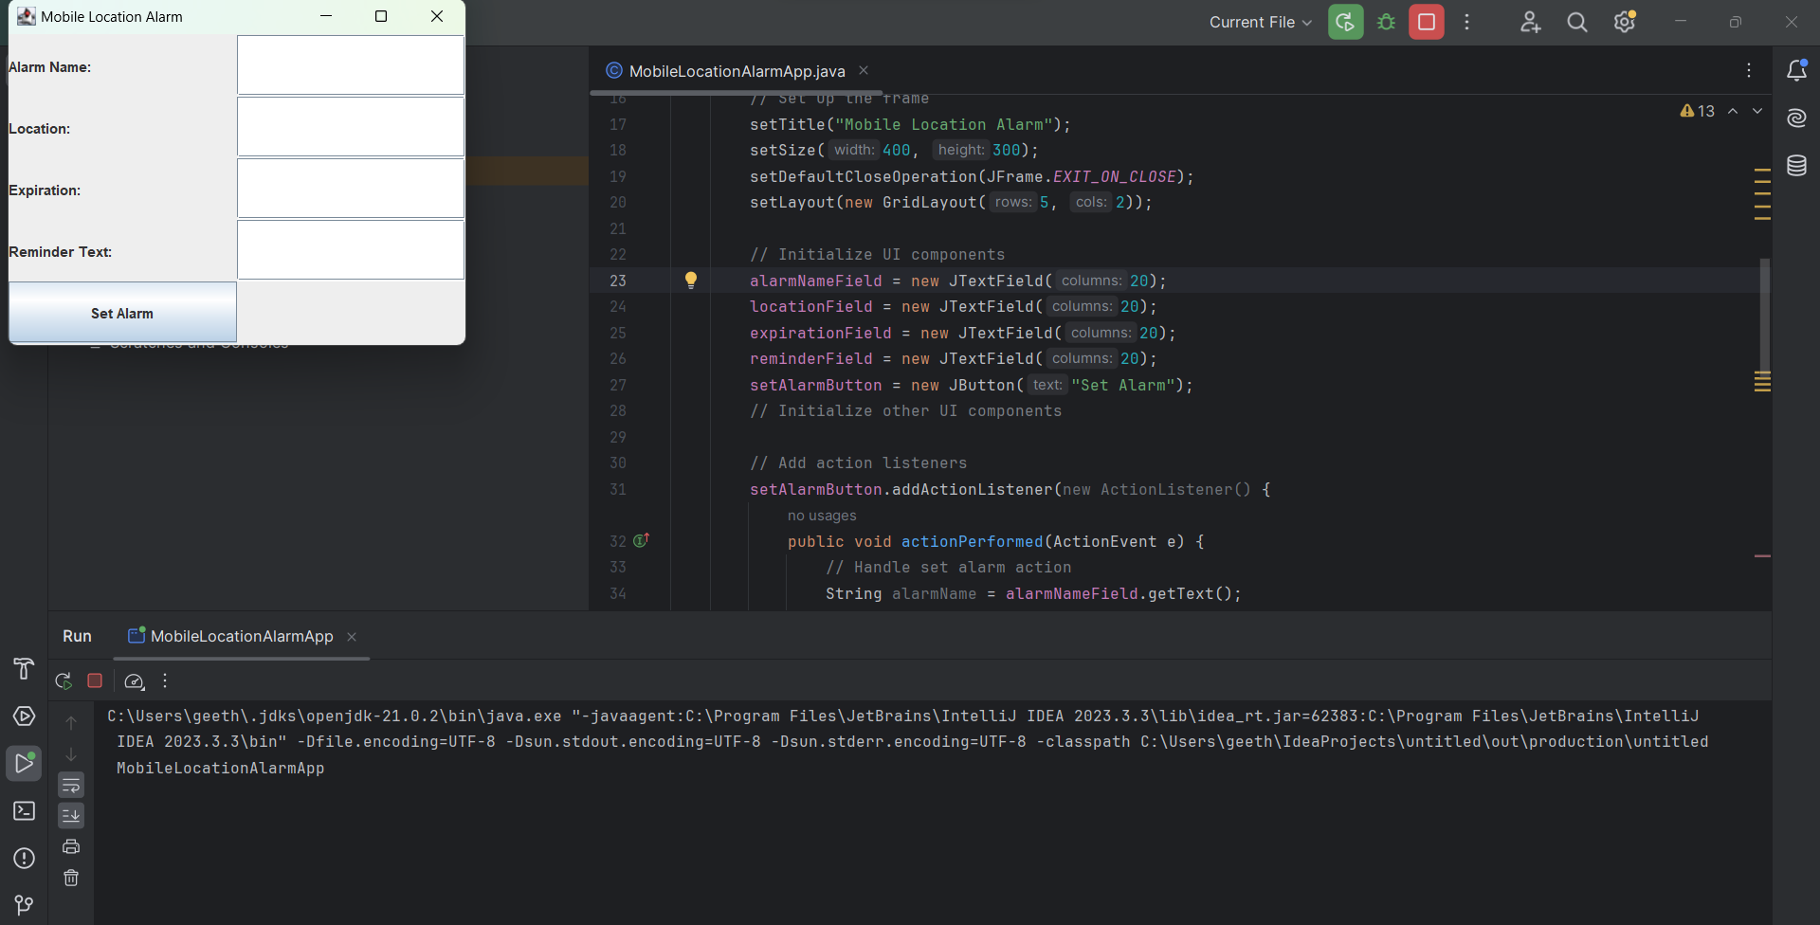

# CONCLUSION

In conclusion, the Mobile Location Alarm represents a significant advancement in the realm of personal organization and task management, leveraging the capabilities of modern smartphones to enhance efficiency and convenience. Throughout this exploration, we have seen how this innovative application harnesses GPS technology to provide users with location-based reminders and alerts tailored to their specific needs and routines.

By allowing users to set reminders based on their geographical location, the Mobile Location Alarm enables a new level of automation and context-awareness in task management. Whether it's remembering to pick up groceries when passing by the store or being reminded of an important meeting upon arrival at the office, this system ensures that important tasks are never forgotten.

The versatility of the Mobile Location Alarm extends across various domains, catering to the needs of professionals, students, parents, and individuals alike. Its intuitive interface, customizable features, and seamless integration with smartphone functionalities make it a valuable tool for enhancing productivity and staying organized in today's fast-paced world.

# FUTURE ENHANCEMENT

1. **Advanced Geofencing Features**: Enhance the geofencing capabilities of the system to support more complex and customizable geofences. This could include the ability to define irregularly shaped boundaries, set multiple concentric zones, or specify dynamic geofences based on real-time data.
2. **Integration with Smart Home Devices**: Enable integration with smart home devices and platforms, allowing users to trigger actions or control devices based on their location. For example, users could set their smart thermostat to adjust the temperature when they arrive home or turn on lights when they enter a specific room.
3. **Machine Learning Algorithms**: Implement machine learning algorithms to analyze user behavior patterns and automatically suggest or adjust location-based reminders. By learning from user interactions and preferences over time, the system can provide more personalized and context-aware alerts.

## REFERENCES

[1] http://www.instantfundas.com/2011/11/3-location-based-

alarms-that-wake-you.html, accessed February 2013.

[2] http://code.google.com/p/bus-stop-alarm/, accessed

February 2013.

[3] http://www.projecttopics.info/Java/Mobile_Location_Ala

rm.php, accessed February 2013.

[4] http://en.wikipedia.org/wiki/Android_

(operating_system), accessed February 2013.

[5] http://brage.bibsys.no/uis/bitstram/URN:NBN:no-

ibsys_brage_75971/1/Tjensvold,%20 Jan%20Magne.pdf,

accessed February 2013